# Screenshots

## 1 Online mode:

### 1.0 Local Storage and Console Display of default city

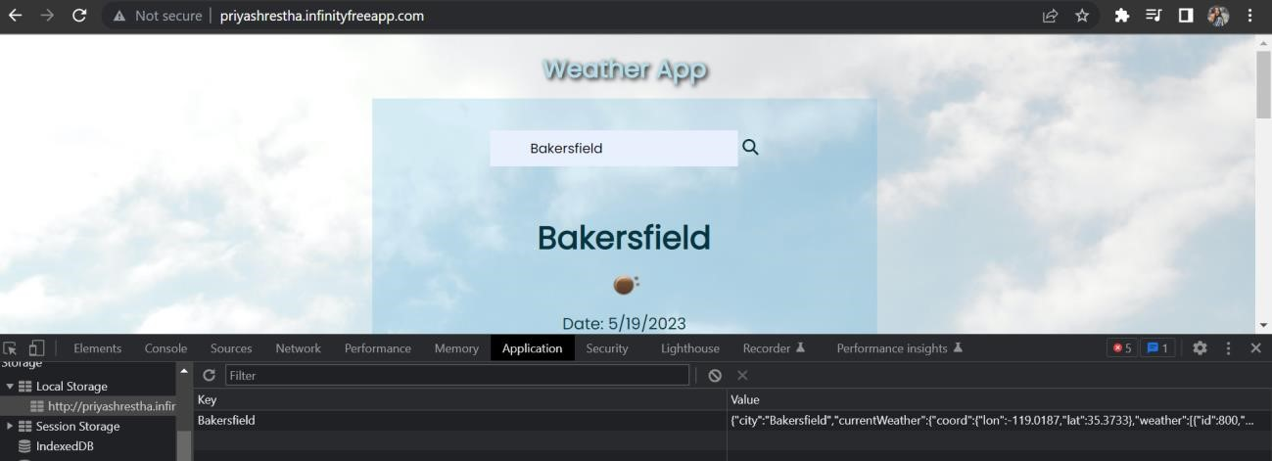

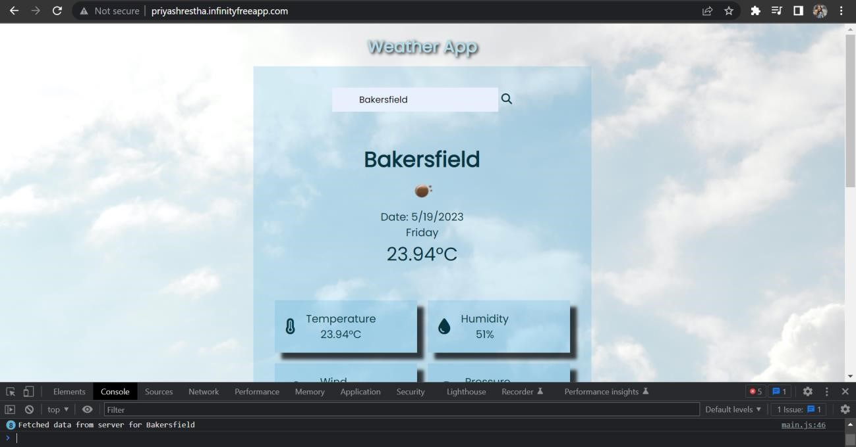

### 

### 1.1 Webpage Display of 7 days weather forecast of default city

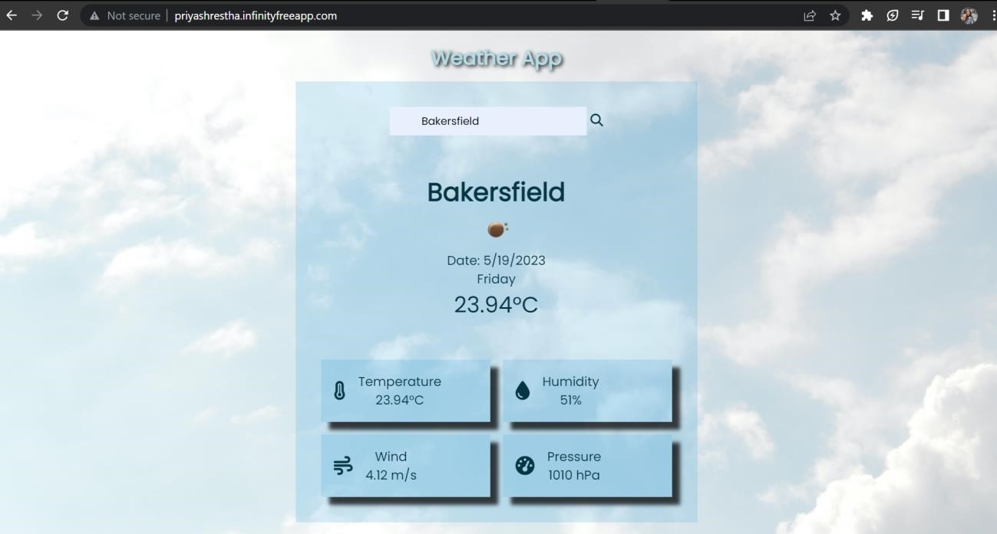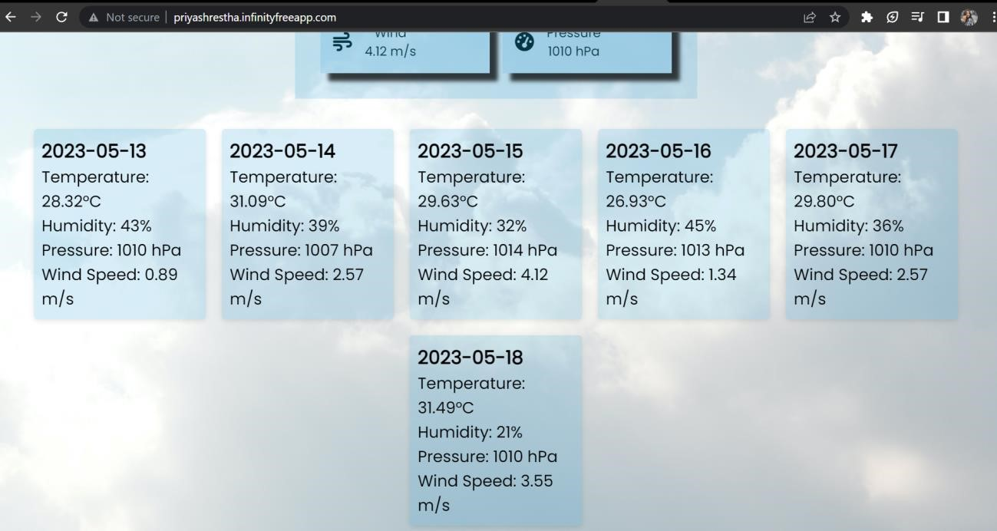

### 

### 1.2 Searched city Webpage display showing 7 days weather data:

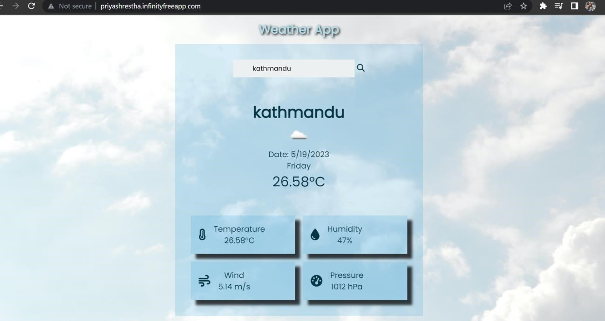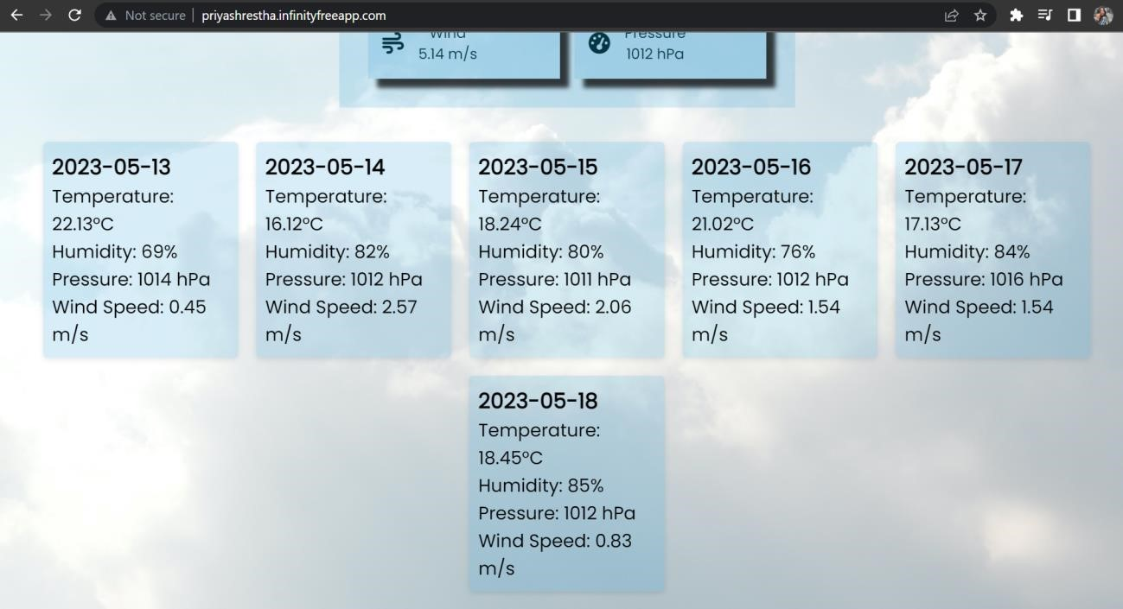

### 1.3 Searched city Local Storage and console display:

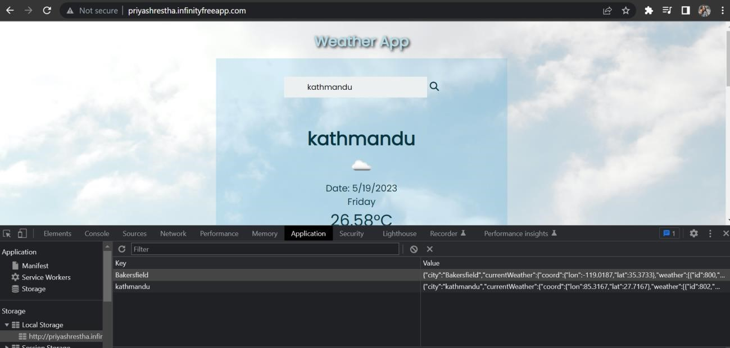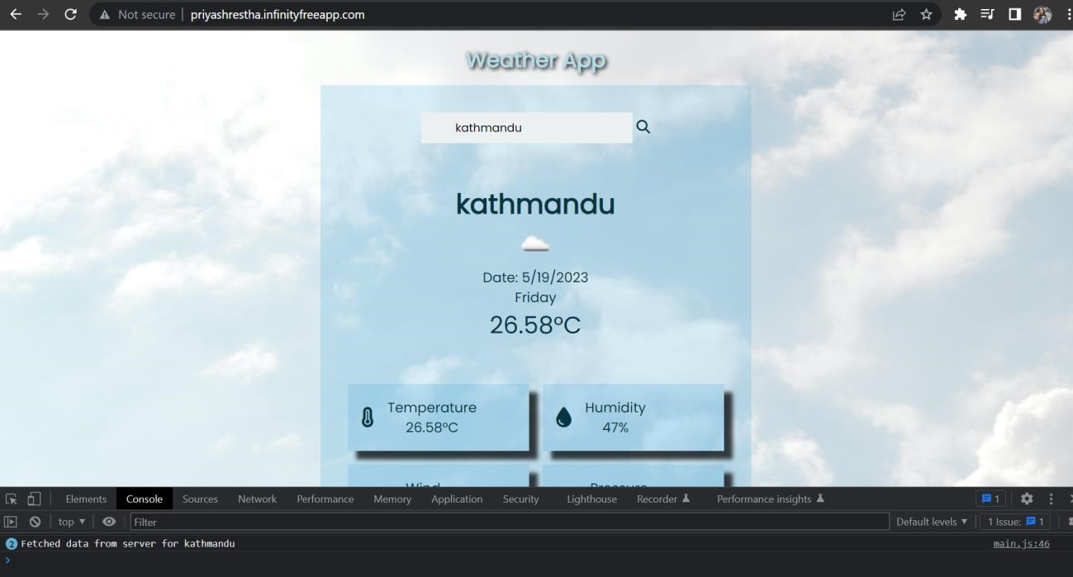

## 2 OFFLINE MODE:

### 2.0 Webpage Display of “DEFAULT CITY “ in offline mode:

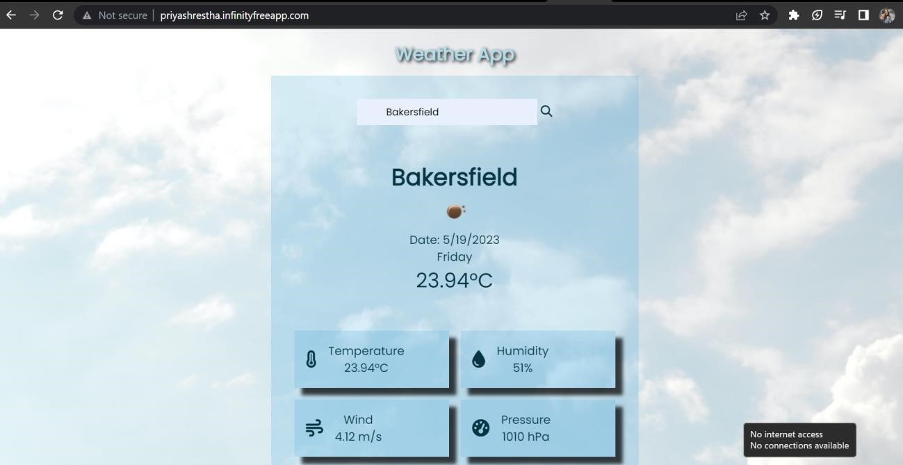

### 

### 2.1 Console and local storage Display of “Default City” in offline mode:

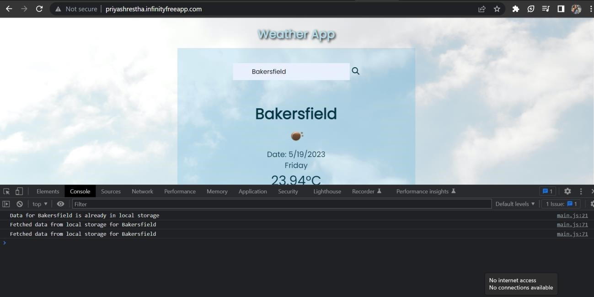

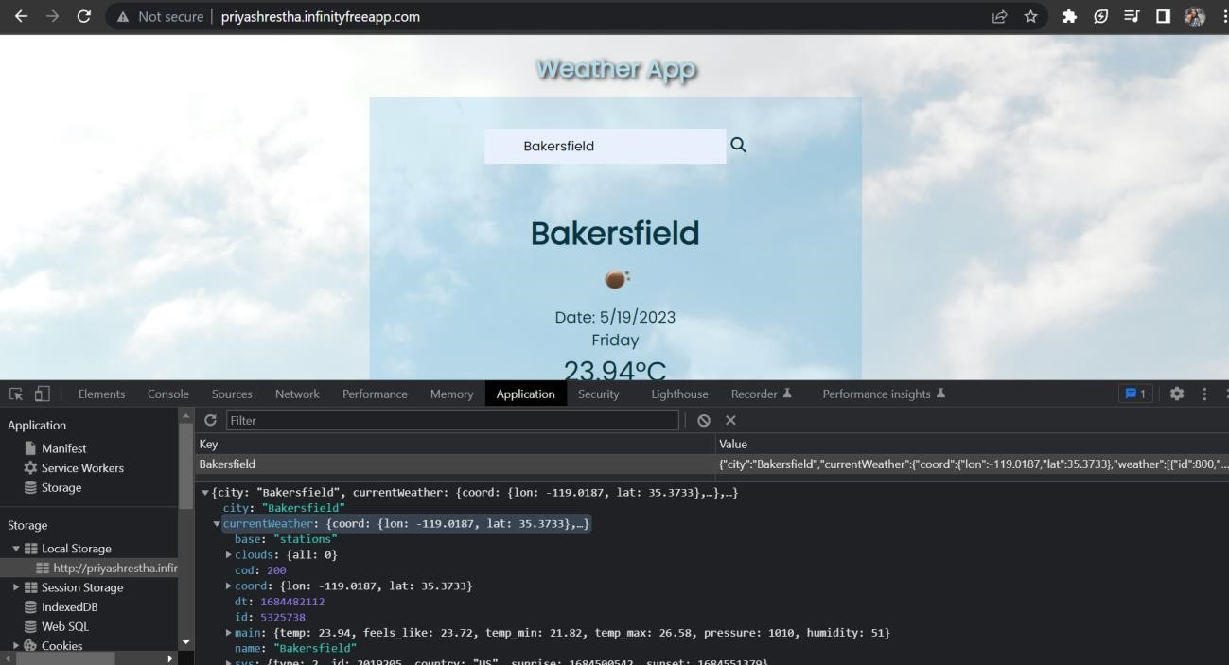

### 

### 2.2 Webpage Display of “Searched City “ in offline mode:

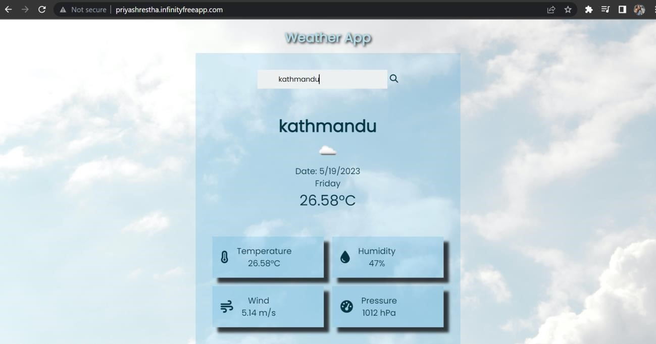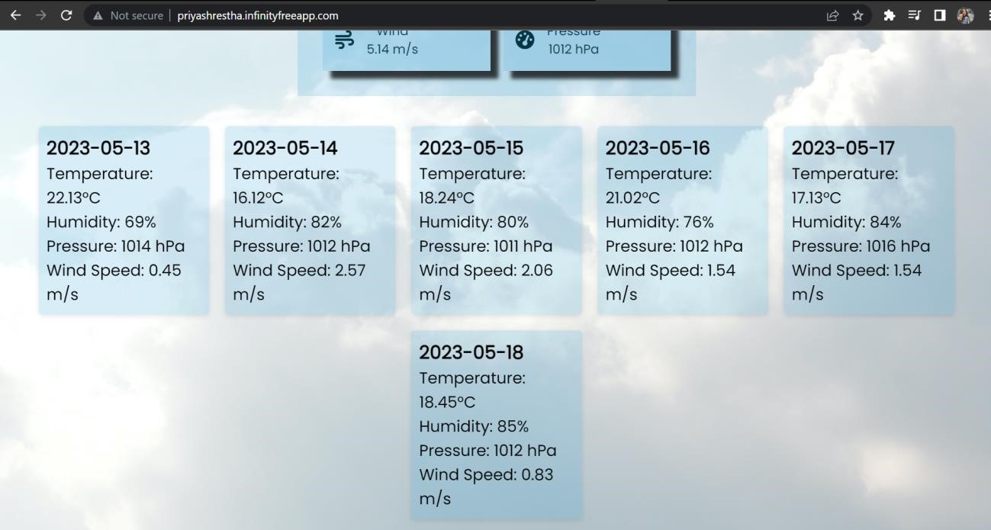

### 2.3 Console and local storage Display of “Searched City” in offline mode:

